James Brown

CSD-340

Web Development with HTML & CSS

Module 2.2 Assignment

8/14/2022

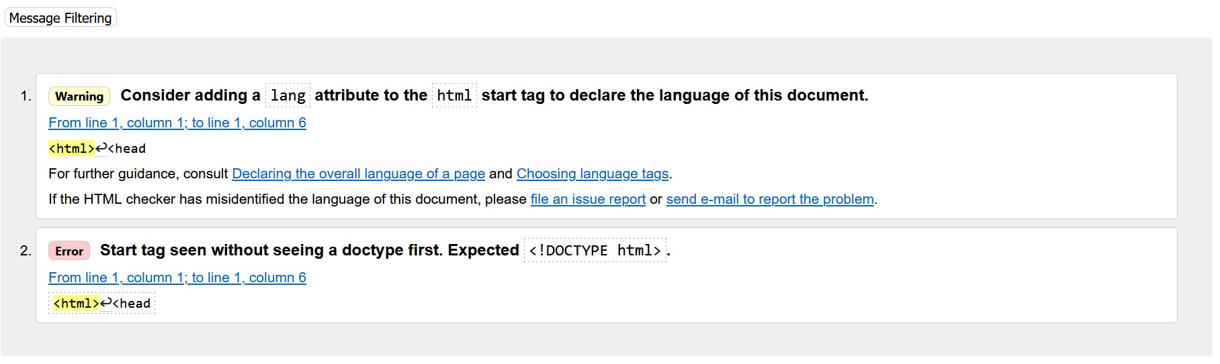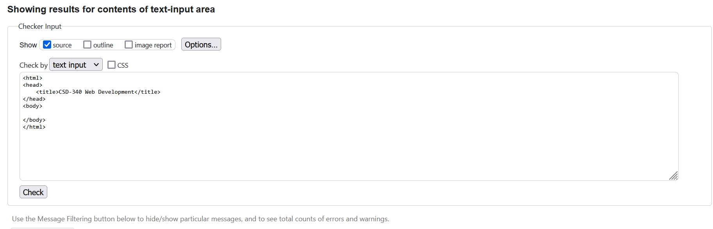Screenshot 1

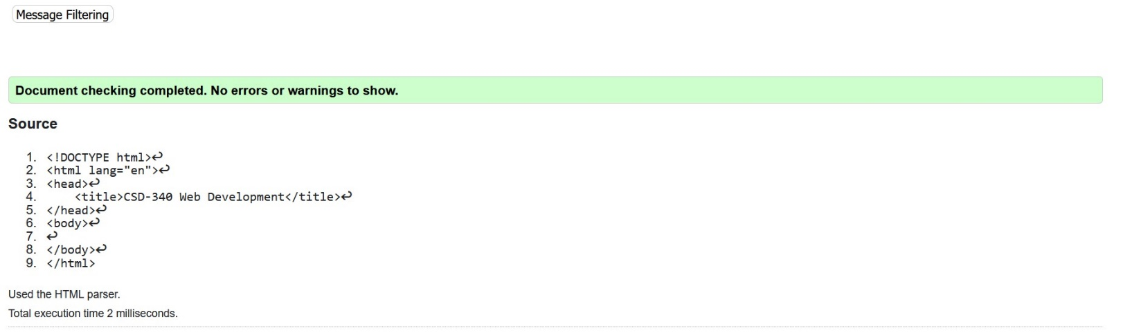**Screenshot 2**

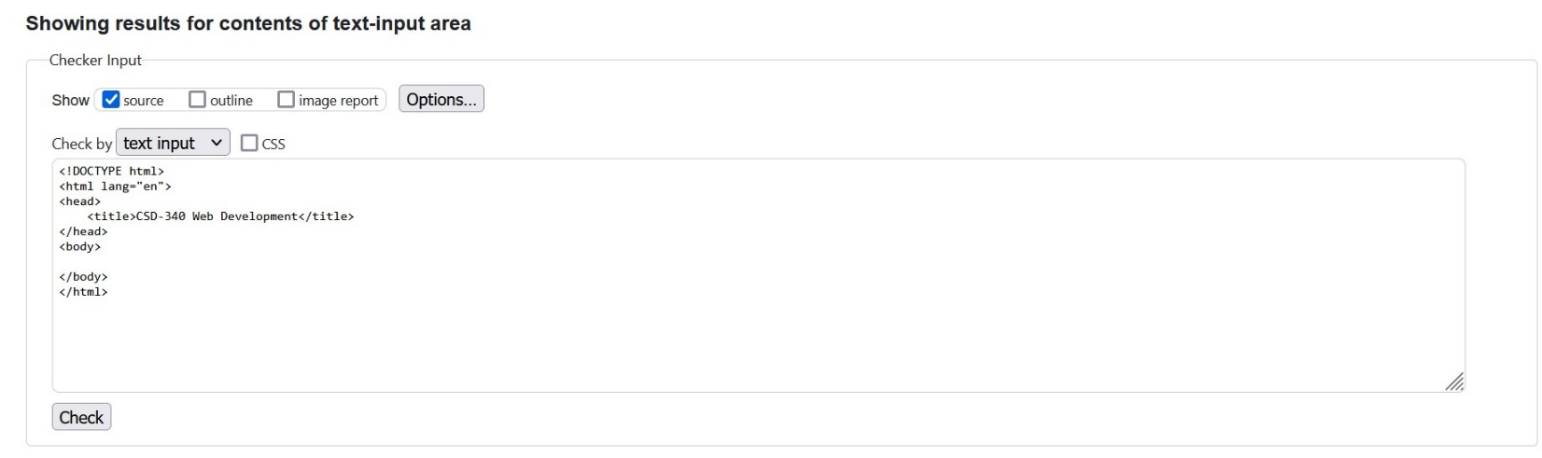

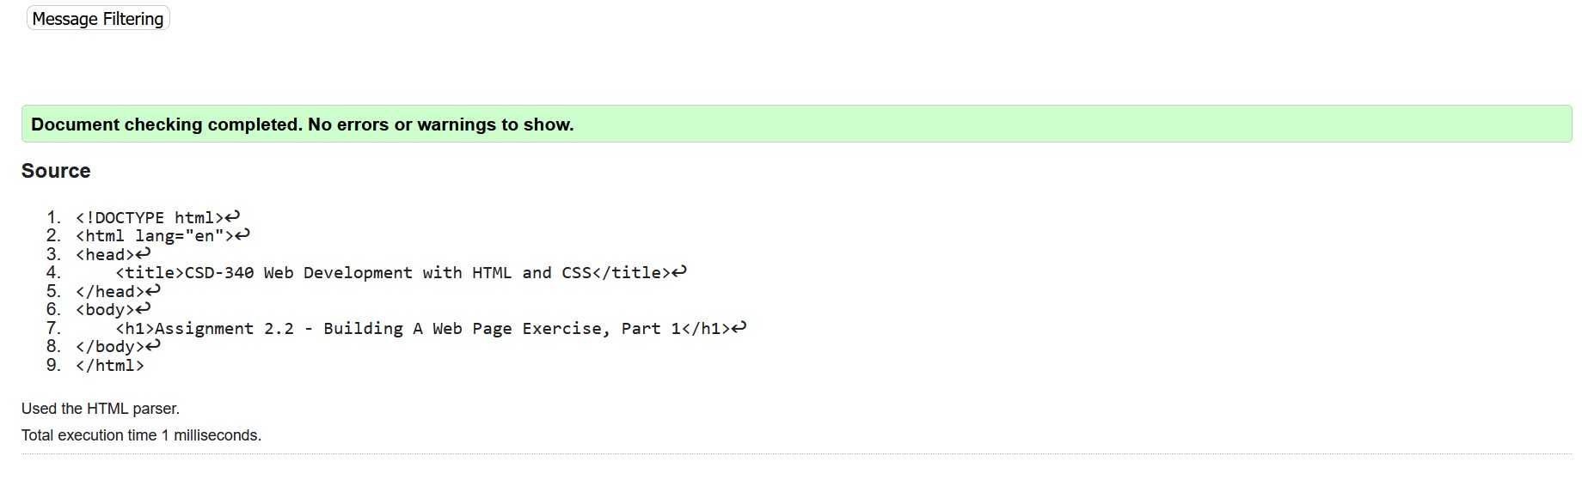**Screenshot 3**

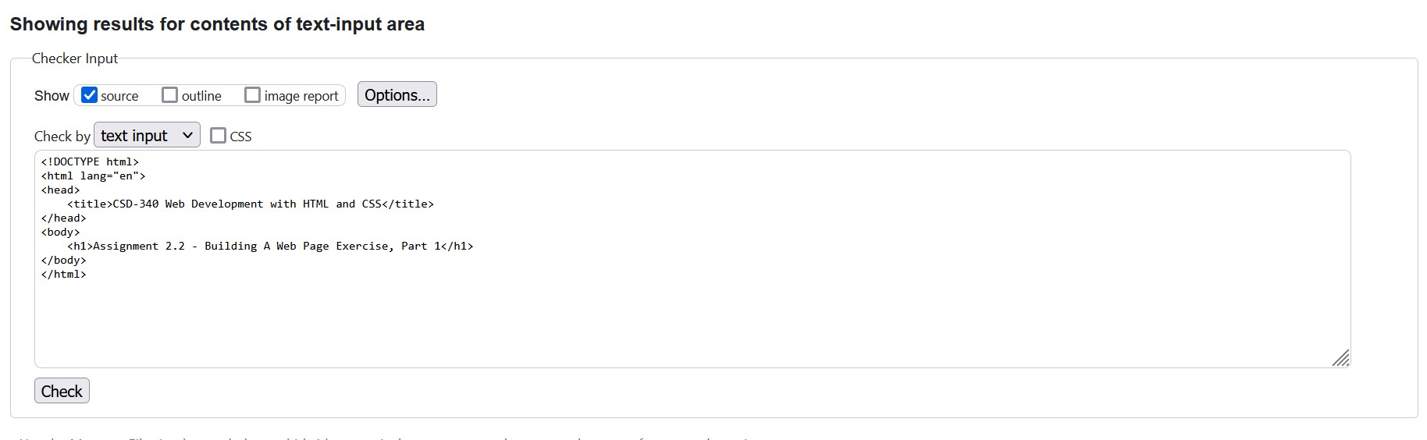

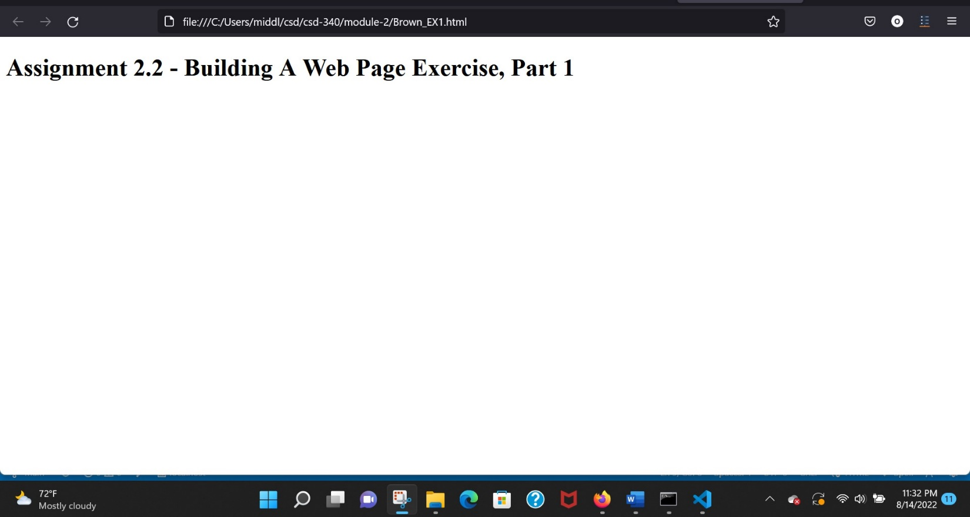**Screenshot 4**